PRACTICAL REPORT
Identifying Running Processes with TCPView
Windows Sysinternals Suite — Class Activity 3.0.3
Field | Details
Name | Emmanuel Aidoo
Course / Instructor | [Enter course and instructor]
Date performed | 5 October 2026
Environment | Windows 11 (build 10.0.26100)
Tool used | TCPView (Tcpview.exe), Windows Sysinternals Suite

Privacy note: All IP addresses in this report, including those inside the screenshots, have been replaced with fictional values. Local addresses use 10.10.10.x and 10.20.x.x, and remote addresses use the reserved documentation ranges 192.0.2.x, 198.51.100.x and 203.0.113.x.

1. Summary
I used TCPView to inspect the processes running on my Windows PC and the network endpoints each one owns. I opened the properties of three core Windows processes (lsass.exe, wininit.exe and spoolsv.exe) to confirm what they are and where they run from, then opened and closed Google Chrome to see how a user application appears in, and disappears from, the list. I also recorded what TCPView's row colours mean and what the status bar counts showed at each stage.

2. Practical Work Performed

2.1 Viewing the running processes
TCPView lists every TCP and UDP endpoint on the machine, with the owning process, its ID, protocol, state, local and remote address and port, creation time and the Windows service (module) behind it.
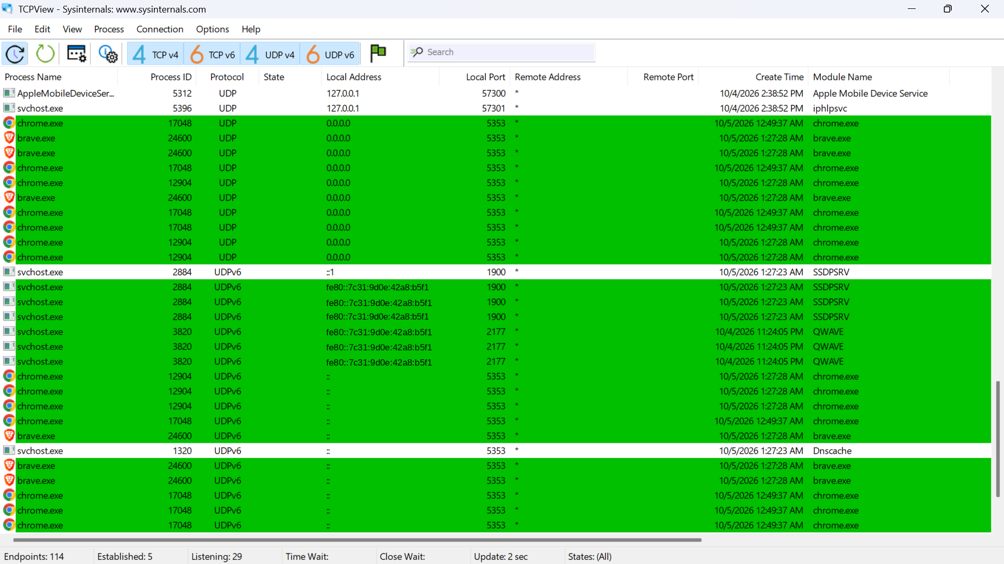
Figure 1: TCPView listing the processes currently running, with browser UDP endpoints highlighted
Figure 1 was captured with Chrome (process IDs 17048 and 12904) and Brave (process ID 24600) still running, so it also shows their UDP port 5353 endpoints in green. The status bar showed 114 endpoints, 5 established and 29 listening. Among the Windows entries, svchost.exe appears several times, each tied to a different service in the Module Name column: SSDPSRV (port 1900), QWAVE (port 2177) and Dnscache (port 5353).
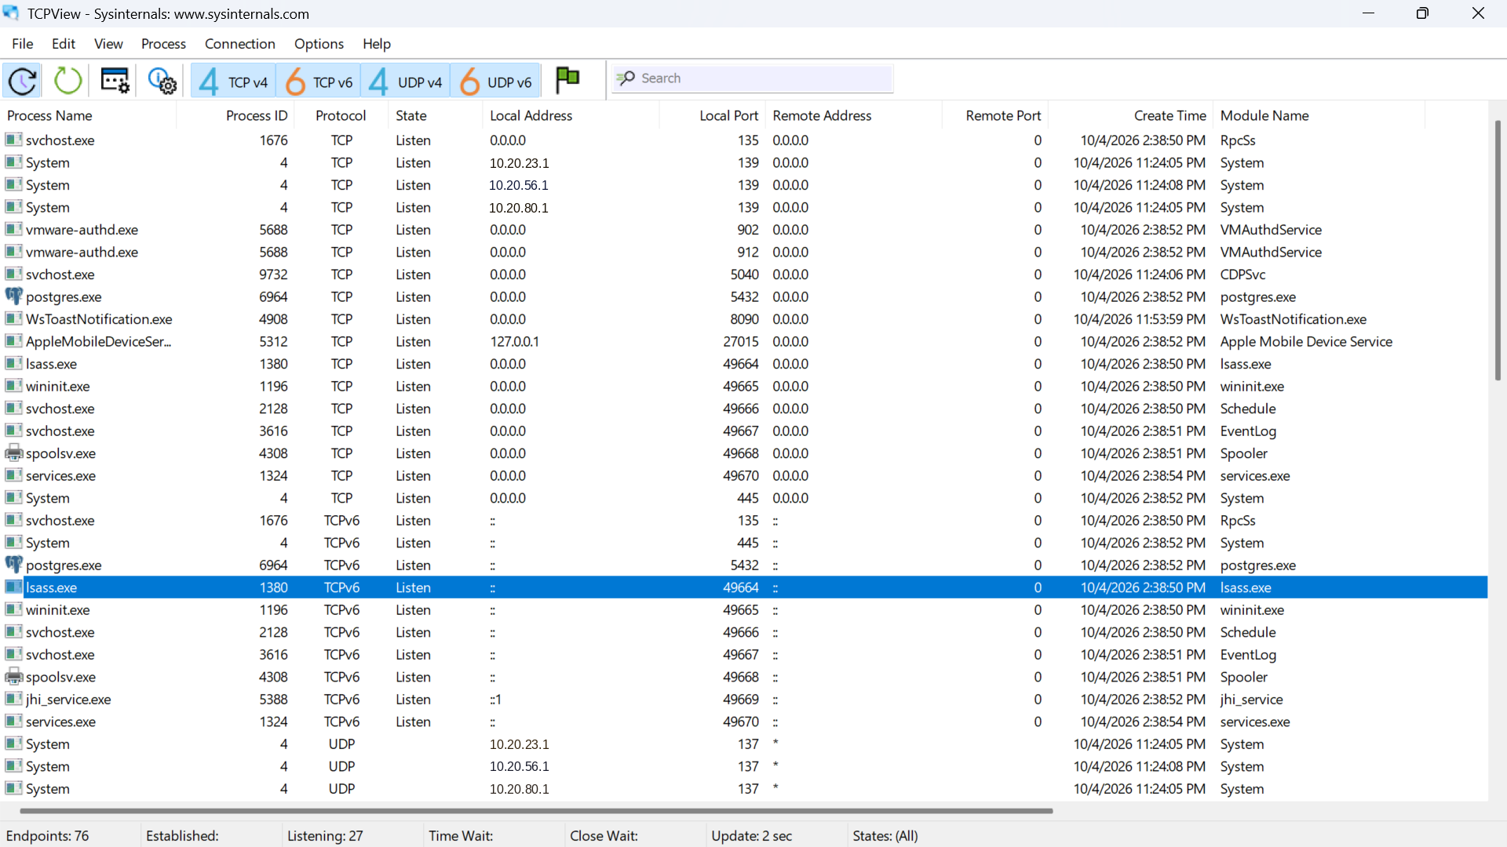
Figure 2: Quieter process list with lsass.exe (PID 1380) selected
Figure 2 shows the list with no browser running: 76 endpoints, 27 listening and none established. Every row was created on 4 October, meaning these processes started with Windows or with installed software rather than by me.

2.2 Inspecting lsass.exe
I selected lsass.exe and opened its properties.
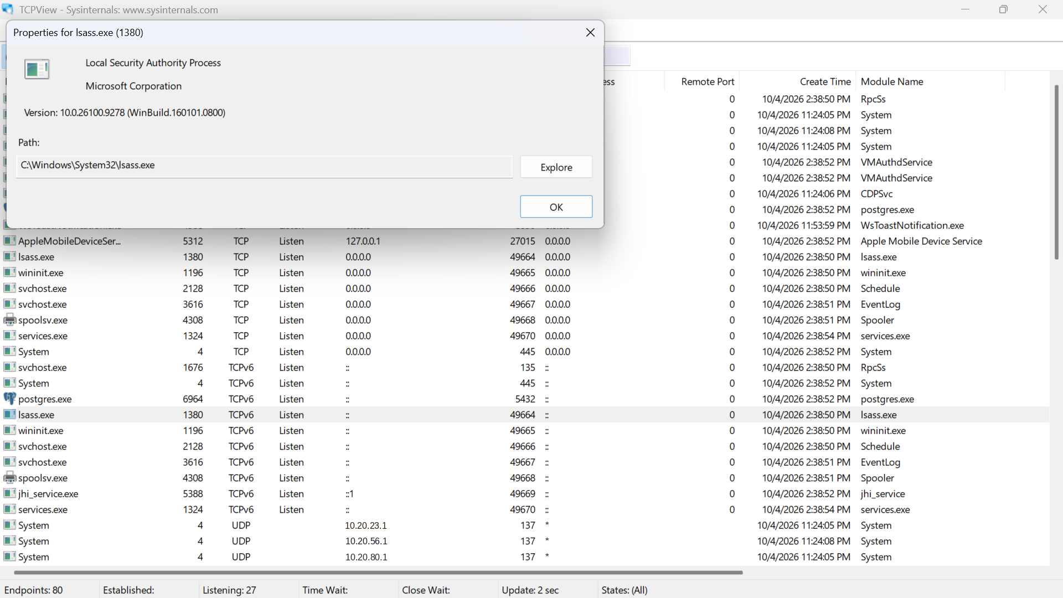
Figure 3: Properties window for lsass.exe (PID 1380)
The properties window identified it as Local Security Authority Process, published by Microsoft Corporation, version 10.0.26100.9278, running from C:\Windows\System32\lsass.exe.

2.3 Inspecting other processes
I then checked two further Windows processes.
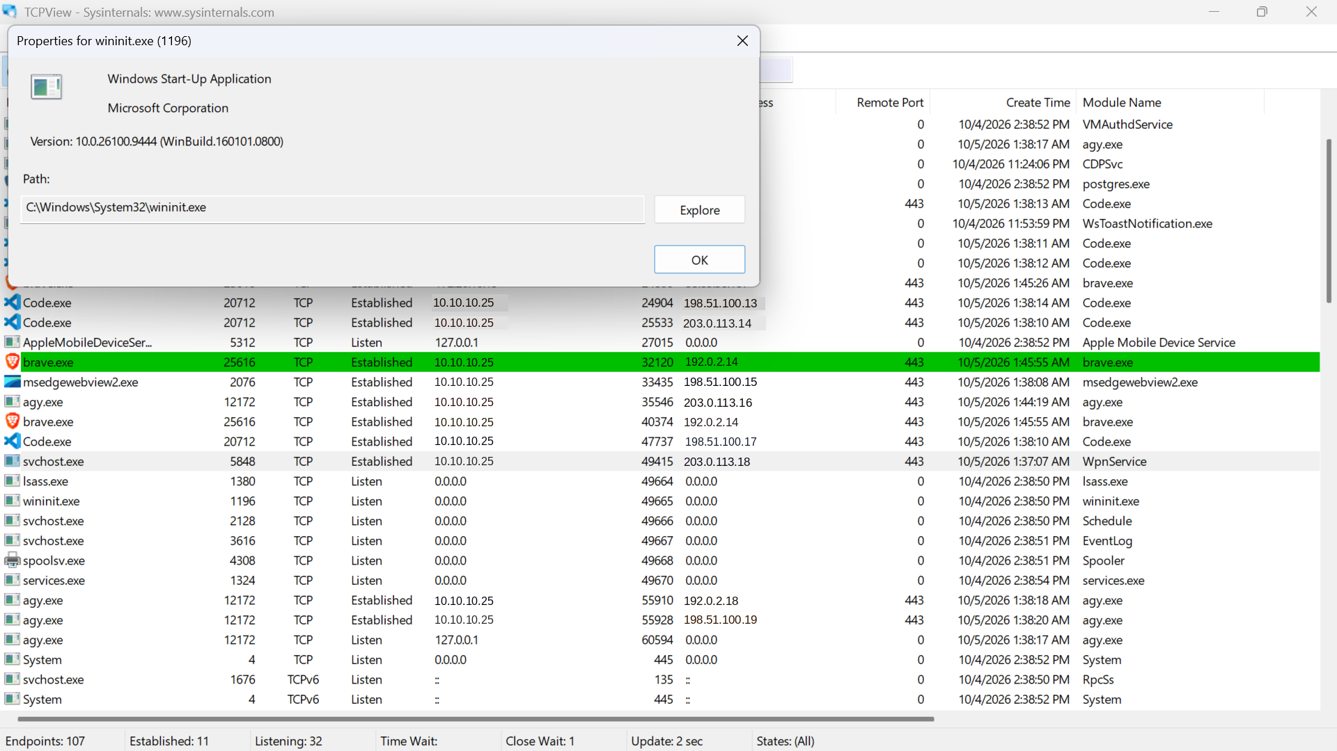
Figure 4: Properties window for wininit.exe (PID 1196)
wininit.exe is described as Windows Start-Up Application (Microsoft Corporation, version 10.0.26100.9444) and runs from C:\Windows\System32\wininit.exe.
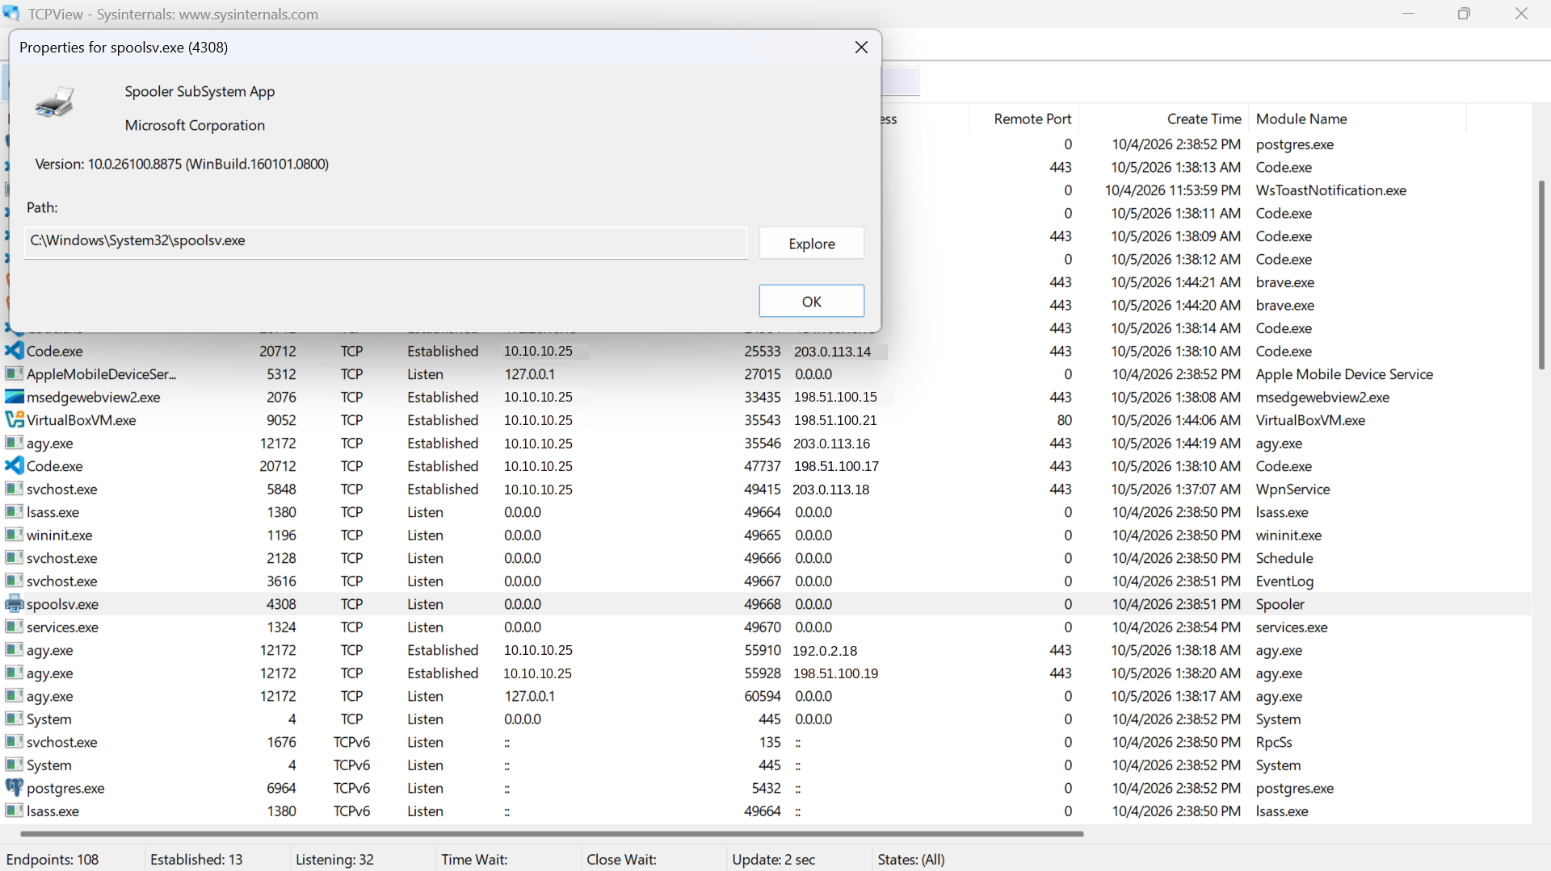
Figure 5: Properties window for spoolsv.exe (PID 4308)
spoolsv.exe is described as Spooler SubSystem App (Microsoft Corporation, version 10.0.26100.8875) and runs from C:\Windows\System32\spoolsv.exe. It is the Windows print spooler.

2.4 Opening and closing a web browser
I opened Chrome and watched TCPView, then closed it and watched again.
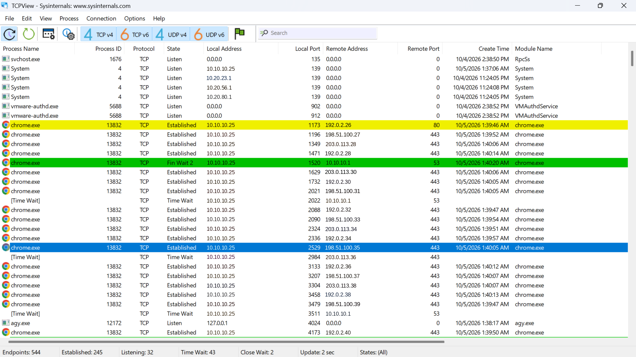
Figure 6: TCPView after opening Chrome
Within seconds the status bar jumped to 544 endpoints, with 245 established and 43 in Time Wait, compared with 76 to 80 endpoints before. Nearly all the new rows belonged to chrome.exe (PID 13832), connecting to remote servers on port 443 (HTTPS), with one on port 80 (HTTP).
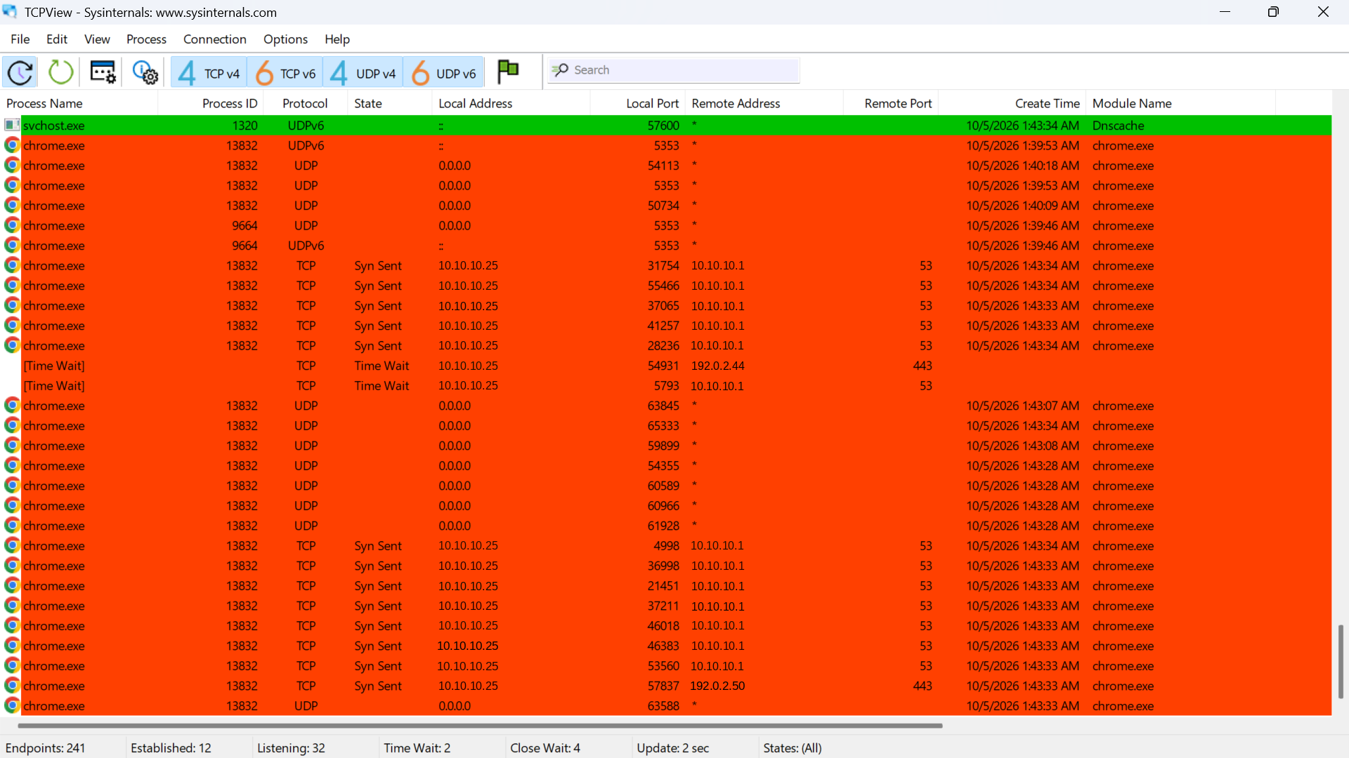
Figure 7: TCPView while Chrome is closing
As Chrome shut down, its rows turned red and began to disappear. The count fell to 241 endpoints, with only 12 established, 2 in Time Wait and 4 in Close Wait. The remaining chrome.exe rows were mostly in the Syn Sent state, which means connection attempts that never completed, aimed at port 53 of the local gateway (10.10.10.1). Port 53 is DNS, so these were name lookups.

3. What the TCPView Colours Mean
TCPView refreshes every two seconds (the status bar shows "Update: 2 sec"). Colours highlight what changed since the last refresh and fade back to white afterwards.
Colour | Meaning | Where I saw it
Green | New endpoint: it appeared since the last refresh. | Figure 1: browser UDP port 5353 rows. Figure 6: a Fin Wait 2 DNS row. Figure 7: a new svchost.exe (Dnscache) row.
Red | Endpoint being removed: it is closing and will vanish at the next refresh. | Figure 7: the chrome.exe rows as Chrome was closed.
Yellow | The endpoint changed state, for example from Syn Sent to Established. | Figure 6: the first chrome.exe row, the HTTP connection on port 80.
Blue | Row selected by me with the mouse. This is not a status colour. | Figure 2 (lsass.exe) and Figure 6 (a chrome.exe row).
White | Unchanged endpoint, already present at the previous refresh. | The Windows service rows in every figure.

Seeing green rows appear as an application starts and red rows as it exits is the quickest way to tell what a program is doing on the network at a given moment.

4. Findings

4.1 Properties of the processes I inspected
Process | PID | Description shown | Version | Path
lsass.exe | 1380 | Local Security Authority Process | 10.0.26100.9278 | C:\Windows\System32\lsass.exe
wininit.exe | 1196 | Windows Start-Up Application | 10.0.26100.9444 | C:\Windows\System32\wininit.exe
spoolsv.exe | 4308 | Spooler SubSystem App | 10.0.26100.8875 | C:\Windows\System32\spoolsv.exe

All three are published by Microsoft Corporation and run from C:\Windows\System32\, which is where genuine copies are expected. lsass.exe verifies the validity of user logins to the PC, wininit.exe is part of Windows start-up, and spoolsv.exe manages print jobs.

4.2 Listening ports of Windows processes
Several Windows processes were in the Listen state on consecutive high ports, bound to all interfaces (0.0.0.0, and :: for IPv6):
Process (module) | Port | Note
lsass.exe | 49664 | Local Security Authority
wininit.exe | 49665 | Windows start-up
svchost.exe (Schedule) | 49666 | Task Scheduler service
svchost.exe (EventLog) | 49667 | Event Log service
spoolsv.exe (Spooler) | 49668 | Print spooler
services.exe | 49670 | Starts and stops services

These ports sit in the high range Windows uses for dynamic RPC. Other Windows endpoints I noticed were svchost.exe (RpcSs) on port 135, and System (PID 4) on port 445 and, per network adapter, ports 139 and 137. Port 445 is Windows file sharing (SMB).

4.3 Reading svchost.exe correctly
The same file name, svchost.exe, appeared many times with different process IDs. The Module Name column showed that each instance hosts a different service, including RpcSs, Schedule, EventLog, Dnscache, SSDPSRV, QWAVE, WpnService, CDPSvc and iphlpsvc. This matches the lab's description of svchost.exe as the Service Host that handles the sharing of system resources.

4.4 Non-Windows processes in the list
Even with no applications open, TCPView showed processes from installed software, so the baseline was not purely Windows: vmware-authd.exe (ports 902 and 912), postgres.exe (port 5432), AppleMobileDeviceService (localhost only), jhi_service.exe, WsToastNotification.exe (port 8090) and, when running, Code.exe, msedgewebview2.exe, VirtualBoxVM.exe, brave.exe and chrome.exe. I also saw agy.exe (PID 12172), which I did not identify. Opening its properties would confirm its publisher and location.

4.5 Processes researched
Process | What it does | Location | Path confirmed
lsass.exe | Verifies user logins (Local Security Authority Process). | C:\Windows\System32\ | Yes
wininit.exe | Windows Start-Up Application. | C:\Windows\System32\ | Yes
spoolsv.exe | Spooler SubSystem App (print spooler). | C:\Windows\System32\ | Yes
services.exe | Starts and stops services; changes default service startup settings. | C:\Windows\System32\ (expected) | No
svchost.exe | Service Host; hosts and shares system resources among Windows services. | C:\Windows\System32\ (expected) | No
chrome.exe | Google Chrome; its endpoints appeared on launch and vanished on exit. | Not checked | No

4.6 Security observations
A process name alone proves nothing: malware often copies the names of legitimate Windows processes. The location is what matters. A genuine lsass.exe, wininit.exe, spoolsv.exe, services.exe or svchost.exe runs from C:\Windows\System32\, so a copy running from anywhere else could be a virus, spyware, trojan or worm and should be investigated.
Listening on 0.0.0.0 means a process accepts connections on every network adapter, so services such as SMB, RPC, PostgreSQL and the VMware authentication service are only protected by the firewall rules in place. Reviewing these is a sensible follow-up.

5. Conclusion
TCPView gave me a live, colour-coded view of what is running on my PC and what each process is doing on the network. The properties of lsass.exe, wininit.exe and spoolsv.exe matched what the lab describes, and all ran from C:\Windows\System32\. Opening Chrome raised the endpoint count from 76 to 544, and closing it brought the count back down, confirming that a process's endpoints exist only while it runs. The colours show new, closing and changed endpoints at a glance, and checking a process's path as well as its name is the key habit for spotting suspicious activity.

